Service Vacation to Cusco, Peru
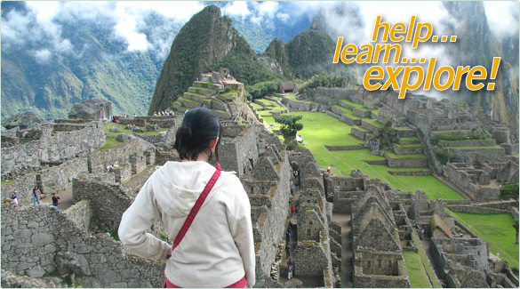
Tentative Dates: March 28-April 4
Estimated Cost: $2000 per person
(Airfare, Transportation, Meals included)

WHY JOIN US?
This is a spectacular opportunity to conduct community service in a developing country while also seeing some of the most spectacular sites in the world. You’ll work/play with children at the Casa de Milagros orphanage and also have the chance to visit ancient Incan ruins and the world famous Machu Picchu!

Activities include:
- Pre-trip orientation and community building
- Volunteering at Casa de Milagros orphanage (working and playing with the children)
- Tours of the ancient city of Cusco and surrounding Incan ruins
- An overnight visit to Machu Picchu
- Easter celebration at the Cusco Cathedral.

The tour will be guided by Craig Dreves, who lived in Peru for a year, speaks Spanish, and has visited Cusco on 2 occasions. As a Peace Corps volunteer, he worked in an orphanage for 2 years in Romania, and has also organized and led three service trips around the world. Beyond this, he has been teaching at Rye Middle School for 5 years, and has a keen insight into the needs of both the Rye community, as well as the needs of our friends in Peru.

WANT MORE INFORMATION – Come to the Information Session!
December 15 at 7:00 pm in the Rye Free Reading Room - Community Room.
Or contact Craig Dreves at DREVEZ@HOTMAIL.COM

Open to all interested families / individuals, but we can only accommodate up to 15 people.
All children must be accompanied by a supervising adult -minimum age is 12 years old.

