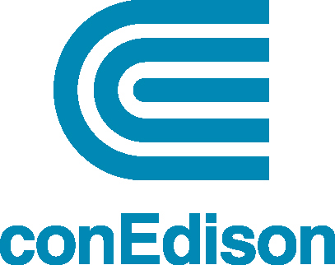

Work Notice

December 16, 2022

Locations: Purchase Street between Purdy Avenue and Locust Avenue – Rye
Estimated Start Date: 1/3/2023
Estimated End Date: 3/15/2023
Contractor Name: Elecnor Hawkeye
Con Edison Construction Supervisor: Randy Toribio
Job Identification: W22-100322988-000WR

A Con Edison contractor will be working in your neighborhood on a gas construction project. The work is scheduled to begin on Tuesday, January 3rd, with an anticipated completion date of Wednesday, March 15th.

- Work will take place from 7:00 A.M. - 5:00 P.M., Monday through Friday.
- Work on Saturday will take place from 9:00AM – 5:00PM

Con Edison staff will be on site and will advise you of any scheduled day work and make every effort to keep disturbances to local businesses and pedestrian traffic at a minimum.

While we work, we’ll need to store supplies and equipment along the road in some areas. We also may need to excavate your sidewalk, driveway or lawn area. If your property is affected, we will restore it. On street parking will be restricted at times. Local Police personnel will be on site for the duration of the project assisting with traffic control.
Please be advised that there is normally a delay between excavation by our contractor crews and the completion of live pipe work by our Gas Department. We will make every effort to expedite the completion of work and minimize the disruption. If you would like to speak with someone in our Gas Department, please call (914) 789-6637 or (914) 789-6877 from 7:00 A.M. to 3:00 P.M. Monday through Friday and your call will be returned promptly.
During the work, we may need to interrupt gas service temporarily. We will notify you in advance if your service will be affected. We will need access to your property to restore your gas service, and we will work with you to accommodate your schedule. Please note that there may also be a delay between the end of the project and the final landscaping or paving restoration, which is completed by different contractors.

For more information or to receive updates on this project, you can contact Con Edison’s Supervisor Randy Toribio at 1-646-946-1534, or e-mail toribior@coned.com. You may also contact Westchester Regional & Community Affairs at 1-914-925-6361, or e-mail dl-WestchesterRCA@coned.com

